OVERVIEW
In today’s fast-paced digital world, people expect services to be delivered instantly with just a few clicks. From food delivery to transportation, technology has transformed the way services are accessed. However, when it comes to household maintenance such as plumbing, electrical repairs, cleaning, or appliance servicing, many people still rely on traditional methods of finding workers, which can be slow, inconvenient, and unreliable. This creates a gap between the growing demand for instant solutions and the availability of organized home service ty
The Instant Home Service System is an innovative digital platform designed to bridge this gap by providing quick, reliable, and on-demand home services. The system connects users with nearby verified service providers through an intelligent online platform. With a simple interface, users can request services instantly, and the system automatically identifies and assigns the nearest available professional to handle the request. This ensures faster response times and improves the overall service experience.
Unlike conventional service booking systems, the Instant Home Service System focuses on speed, accessibility, and efficiency. By integrating features such as real-time service requests, provider availability tracking, and automated service allocation, the platform ensures that household problems are addressed quickly and effectively. This approach not only enhances convenience for users but also creates better opportunities for service providers by increasing their visibility and job accessibility.
Overall, the Instant Home Service System represents a modern and innovative approach to managing household services. It leverages digital technology to simplify service booking, reduce waiting time, and provide reliable solutions for everyday home maintenance needs.

INTRODUCTION
The Instant Home Service System is a digital platform will be developed in future to provide fast and convenient household services to users within a very short time, typically around 10 minutes after placing a request. In modern urban life, people often face sudden problems at home such as electrical faults, plumbing leaks, appliance breakdowns, or the need for quick cleaning services. Finding a reliable service provider quickly can be difficult and time-consuming. The 10-Minute Home Service System addresses this issue by connecting customers with nearby service professionals through an online platform.
The system allows users to register and log in through a website or mobile application. After logging in, users can browse different categories of services such as plumbing, electrical repair, home cleaning, appliance servicing, carpentry, and maid services. Once a service is selected, the user can place a request, and the system automatically identifies the nearest available service provider based on location and availability. The service provider then receives the request and reaches the customer’s location as quickly as possible, aiming to deliver assistance within 10 minutes.
This system also includes several important modules such as user management, service provider management, service booking, and administration control. Users can view service details, track their service requests, and maintain a history of previous bookings. Service providers can manage incoming requests, update their availability, and provide timely services. The administrator is responsible for managing users, verifying service providers, updating service categories, and monitoring the overall functioning of the system.
The main goal of the 10-Minute Home Service System is to make household service booking faster, easier, and more reliable. By using digital technology and automated service allocation, the system reduces the waiting time for customers and improves the efficiency of service providers. Overall, the platform enhances convenience, saves time, and ensures that customers receive quick and trustworthy assistance for their household needs

Proposed Methodology:
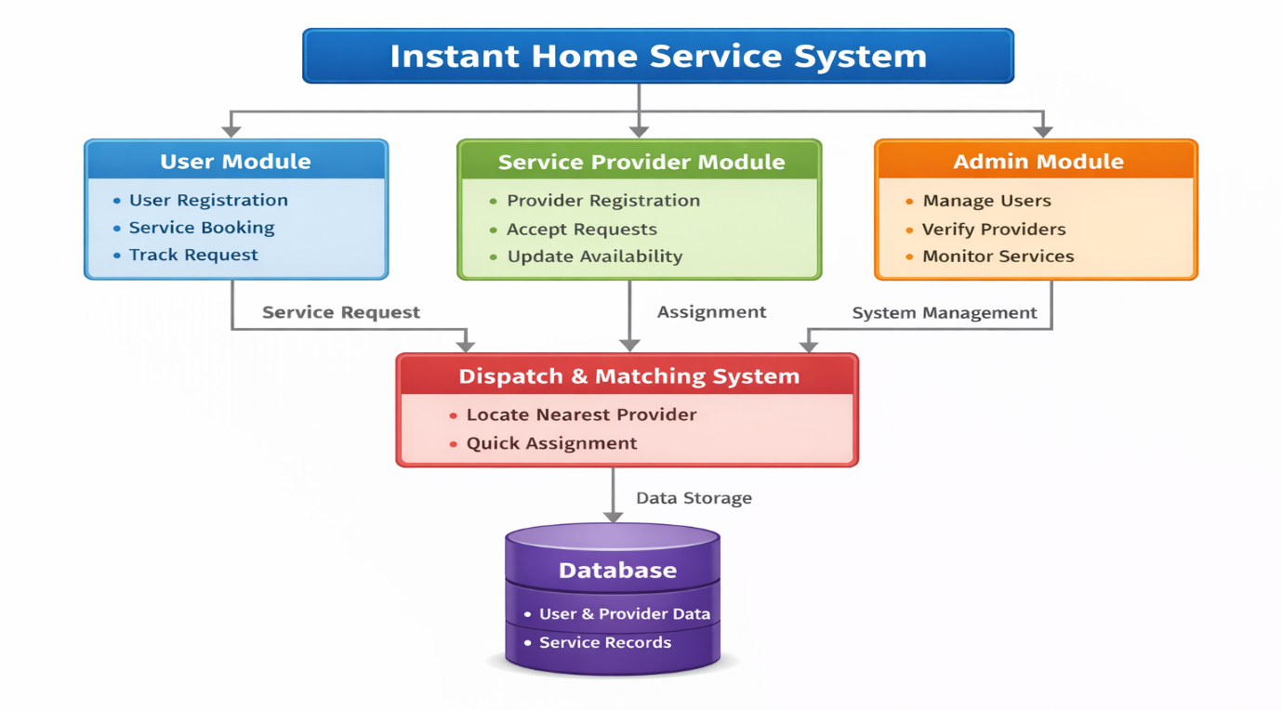
OBJECTIVES :
1.Provide Quick Access to Services:Enable users to book home services (cleaning, plumbing, electrician, etc.) instantly through a digital platform.
2. Reduce Service Waiting Time:Minimize delays by connecting users with nearby available service providers in real-time.
3.Ensure User Convenience:Allow users to schedule, track, and manage services from their mobile or web application.
4.Improve Service Transparency:Display pricing, service details, ratings, and reviews for better decision-making.
5.Enhance Service Provider Opportunities:Create a platform where skilled workers can register and get more job opportunities
6.Enable Secure Online Payments:Provide multiple payment options like UPI, cards, and wallets with secure transactions.
7.Implement Real-Time Tracking:Allow users to track the service provider’s location and service status.
8.Maintain Service Quality:Use feedback and rating systems to ensure high-quality service delivery

OUTCOMES:
1.Faster Service Delivery:Users receive services within minutes, improving overall efficiency.
2. Increased Customer Satisfaction:Easy booking, transparency, and reliability enhance user experience.
3.Time and Effort Savings:Eliminates the need for manual searching and calling service providers.
4.Better Employment Opportunities:Helps local workers gain consistent work and income.
5.Improved Service Reliability:Verified professionals ensure trust and safety.
6. Digital Transformation of Local Services:Traditional home services move to an organized, technology-driven platform
7.Data-Driven Decision Making:System collects user and service data to improve recommendations and operations.
8. Scalable Business Model:Can be expanded to multiple cities and service categories.

